AWS Systems Manager Parameter Store

AWS Systems Manager Parameter Store Documentation
What is AWS Systems Manager Parameter Store?
AWS Systems Manager Parameter Store is a secure storage service in AWS Systems Manager used to store:
- Configuration data
- Secrets
- Passwords
- API keys
- Database connection strings
It helps applications securely retrieve configuration values at runtime.

Why Parameter Store is Used
Instead of hardcoding sensitive information inside applications or scripts, Parameter Store stores them securely and centrally.
Example:
Database Password
API Tokens
SSH Keys
Application Configurations
Environment Variables

Features of Parameter Store
1. Secure Storage
Supports encryption using:
- AWS Key Management Service (KMS)

2. Hierarchical Structure
Parameters can be organized like folders.
Example:
/prod/db/password
/dev/db/password
/app/api/key

3. Versioning
Every update creates a new version automatically.
Example:
Version 1 → old password
Version 2 → new password

4. Access Control
Uses:
- AWS Identity and Access Management (IAM)
to control who can:
- Read parameters
- Update parameters
- Delete parameters

5. Parameter Validation
Can validate:
- Data type
- Allowed patterns

6. Integration with AWS Services
Works with:
- Amazon EC2
- AWS Lambda
- Amazon ECS
- AWS CloudFormation
- AWS CodeBuild

Types of Parameters
Type | Description
String | Plain text value
StringList | Multiple comma-separated values
SecureString | Encrypted sensitive data

Example Parameters
String
/app/environment = production
StringList
/app/servers = web1,web2,web3
SecureString
/db/password = MySecretPassword

Architecture Example
Application
↓
Parameter Store
↓
KMS Encryption

How Parameter Store Works
- Store parameter
- Encrypt using KMS (optional)
- Application requests parameter
- IAM permissions verified
- Parameter returned securely

Create Parameter Using AWS Console
Steps
- Open AWS Console
- Go to Systems Manager
- Select Parameter Store
- Click Create Parameter
- Enter:
  - Name
  - Description
  - Type
  - Value
- Choose encryption if needed
- Create parameter

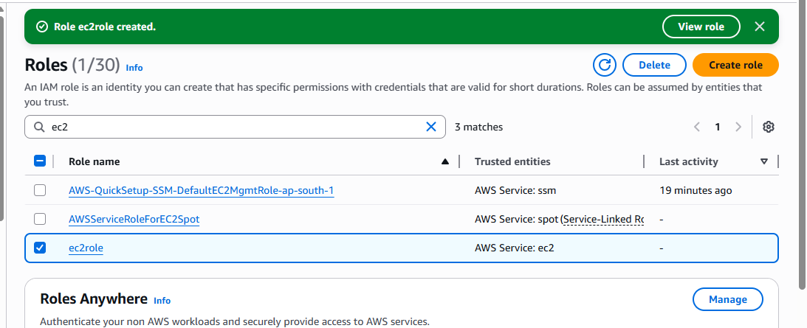

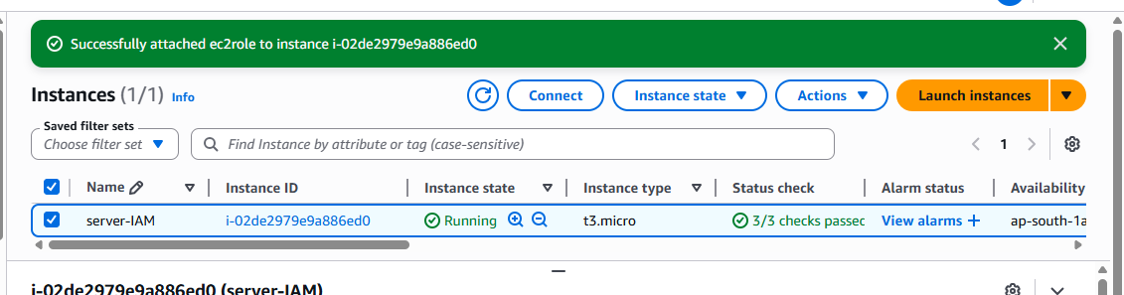

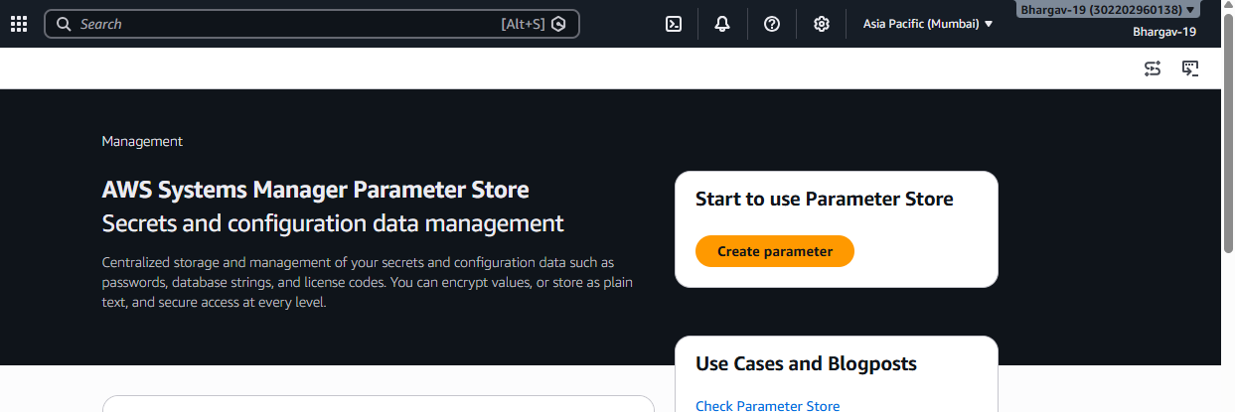

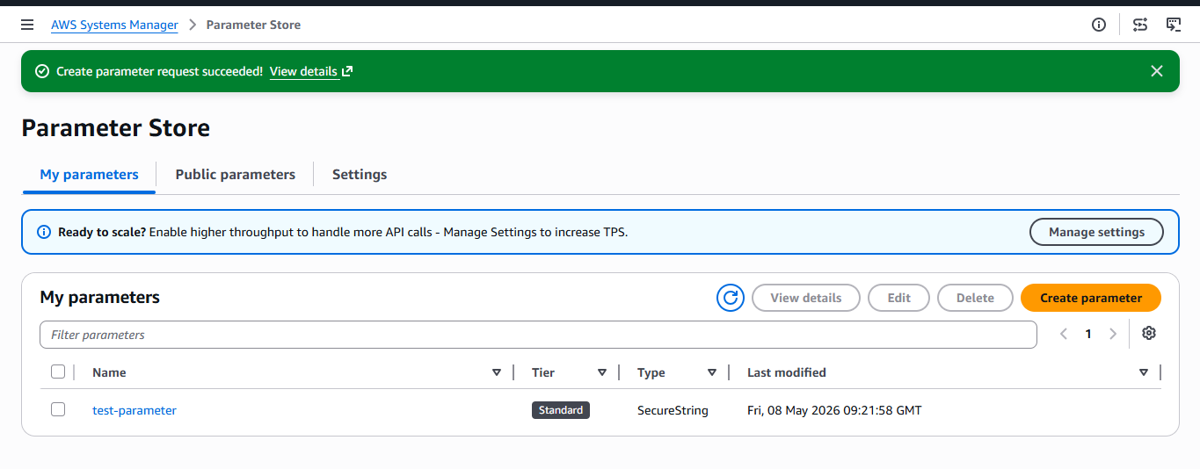

AWS CLI Commands
Get Parameter
aws ssm get-parameter \
--name "test-bhargav" \
--with-decryption

